Throwing an error:

(error “<error message>”)



Let bindings

Syntax:

(let (variable bindings) …body)

Where:

* Variable bindings = [x1 e1] [x2 e2] [x3 e3] …

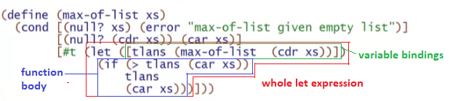

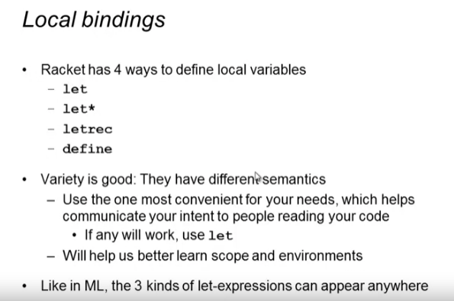

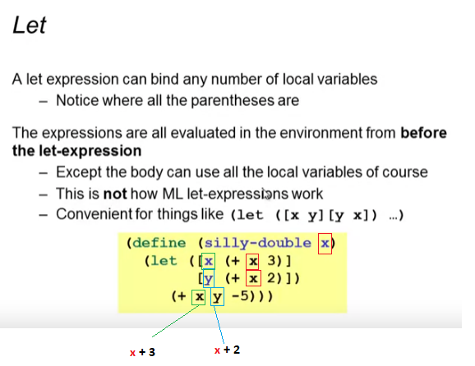

* No shadowing!

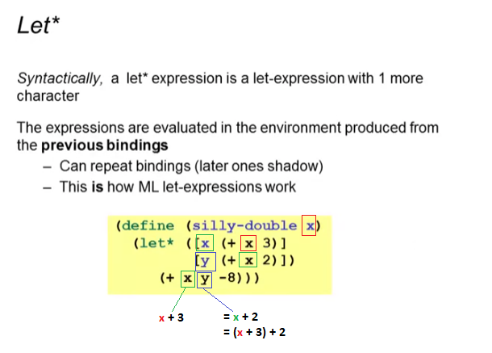

* Has shadowing like ML

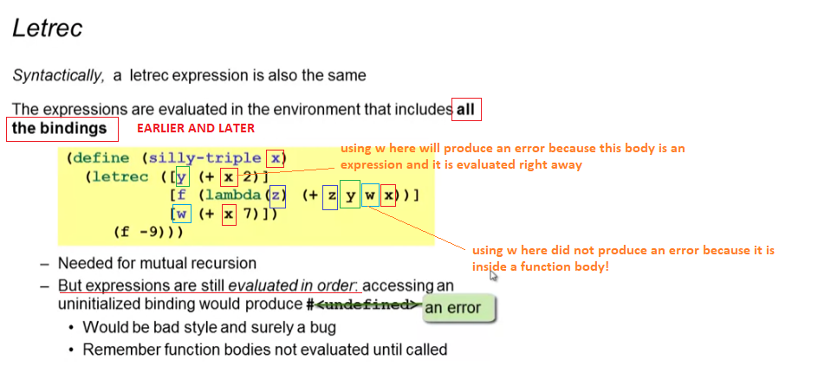

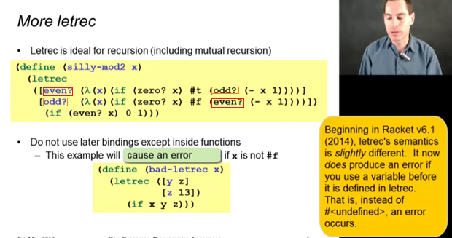

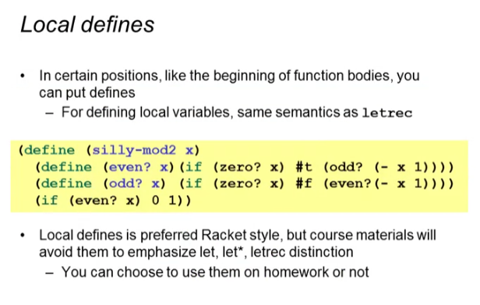

* This is like having const and let inside a function